Classroom Hatching Kits

What’s Inside?
- Large tote
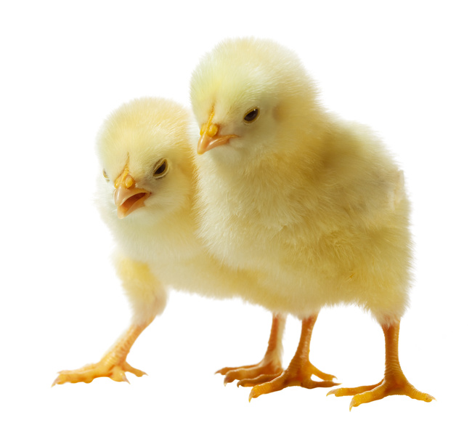
- Incubator
- Incubator manual
- Cardboard hatching mat**
- Feed in small tote
- Shavings
- Cage
- Feeder
- Waterer
- Heat lamp with bulb
- Candler
- Hand sanitizer
- Tips for Classroom Hatching Sheet
- Caution Sign
- Class Hatching Calendar
- Chick Life Cycle 21 Day Egg Set
- 8 Puzzles
- Student workbooks**
- Picture Books:
    - Chicks & Chickens by Gail Gibbons
    - Six Little Chicks by Jez Alborough

**Items we do not need back.

